Software Project Development

Database Design Document

GradeFlow

Team – 8

3 MCA – B

Team Members
2547221 – Ekta Singh
2547240 – Pranav M R
2547250 – Sneha Varghese



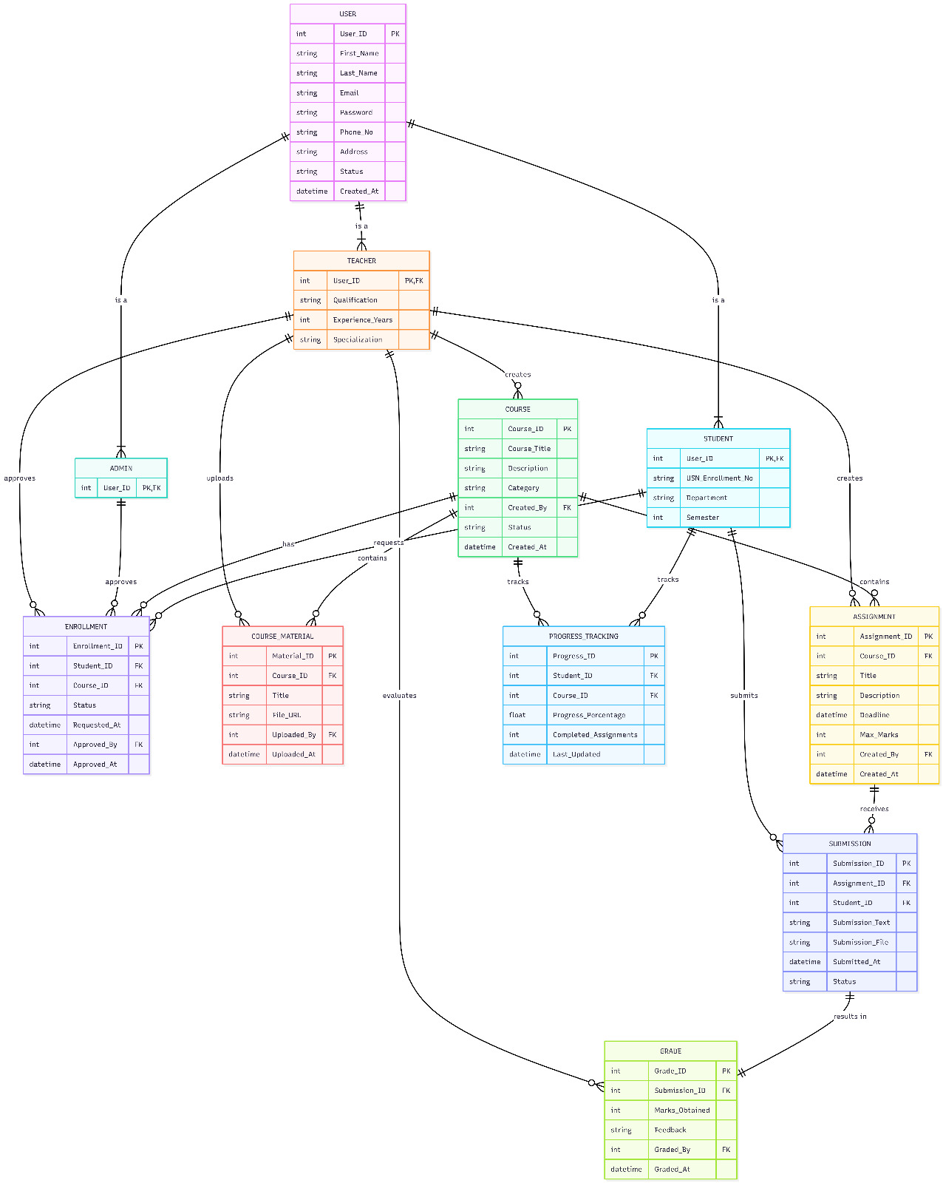

The above Entity–Relationship (ER) diagram illustrates the logical structure of the Learning Management System (LMS) database and clearly defines how each table is interconnected to ensure data integrity, consistency, and efficient data retrieval. The design follows a relational model with well-defined primary keys (PK), foreign keys (FK), cardinalities, and participation constraints.

Core Entity: USER
The USER table acts as the central entity of the system. It stores user-related information, including identification details, authentication credentials, contact information, account status, and timestamps.
- Primary Key: User_ID uniquely identifies each user.
- Other entities reference this table through foreign keys.
- A user can assume one of the following roles: Admin, Teacher, or Student.
- A single user can:
  - Create or manage courses (if Teacher)
  - Enroll in multiple courses (if Student)
  - Approve enrollments (if Admin)
This ensures that all system activities are traceable to a specific authenticated user.

Role Specialization
The system implements specialization using three subtype tables:
- ADMIN
- TEACHER
- STUDENT
Each of these tables uses User_ID as both Primary Key and Foreign Key referencing USER.
- One USER → One role record (disjoint specialization assumed).
- Participation from role tables is total (a role cannot exist without a USER).
This design supports role-based functionality while maintaining normalization.

Course Management
The COURSE table represents academic courses created by teachers.
- Primary Key: Course_ID
- Foreign Key: Created_By → TEACHER(User_ID)
Relationship:
- One TEACHER → Many COURSES (1:N)
- Each course must be created by exactly one teacher.
Attributes include course title, description, category, status, and creation timestamp.

Enrollment Management
The ENROLLMENT table manages student enrollment into courses.
- Primary Key: Enrollment_ID
- Foreign Keys:
  - Student_ID → STUDENT(User_ID)
  - Course_ID → COURSE(Course_ID)
  - Approved_By → ADMIN(User_ID)
Relationships:
- One STUDENT → Many ENROLLMENTS
- One COURSE → Many ENROLLMENTS
- One ADMIN → Many approved enrollments
This table supports request status, approval tracking, and timestamps.

Course Materials
The COURSE_MATERIAL table stores learning resources uploaded for a course.
- Primary Key: Material_ID
- Foreign Keys:
  - Course_ID → COURSE
  - Uploaded_By → TEACHER
Relationship:
- One COURSE → Many COURSE_MATERIAL
- One TEACHER → Many uploaded materials
Attributes include title, file URL, and upload timestamp.

Assignment Management
The ASSIGNMENT table represents coursework assigned to students.
- Primary Key: Assignment_ID
- Foreign Keys:
  - Course_ID → COURSE
  - Created_By → TEACHER
Relationship:
- One COURSE → Many ASSIGNMENTS
- One TEACHER → Many ASSIGNMENTS
Attributes include title, description, deadline, maximum marks, and creation timestamp.

Submission Handling
The SUBMISSION table stores student assignment submissions.
- Primary Key: Submission_ID
- Foreign Keys:
  - Assignment_ID → ASSIGNMENT
  - Student_ID → STUDENT
Relationships:
- One ASSIGNMENT → Many SUBMISSIONS
- One STUDENT → Many SUBMISSIONS
Attributes include submission text, file reference, submission time, and status.

Grading System
The GRADE table records evaluation results for submissions.
- Primary Key: Grade_ID
- Foreign Keys:
  - Submission_ID → SUBMISSION
  - Graded_By → TEACHER
Relationship:
- One SUBMISSION → One GRADE (1:1)
- One TEACHER → Many GRADES
Attributes include marks obtained, feedback, and grading timestamp.

Progress Tracking
The PROGRESS_TRACKING table monitors student performance within a course.
- Primary Key: Progress_ID
- Foreign Keys:
  - Student_ID → STUDENT
  - Course_ID → COURSE
Relationship:
- One STUDENT → Many PROGRESS records
- One COURSE → Many PROGRESS records
Attributes include progress percentage, number of completed assignments, and last updated timestamp.

Cardinality and Participation
The ER diagram uses cardinality indicators (1:1, 1:N, N:1) to define relationships between entities.
- Most relationships follow a One-to-Many (1:N) structure.
- One-to-One (1:1) relationship exists between SUBMISSION and GRADE.
- Participation constraints ensure:
  - Dependent entities (e.g., ENROLLMENT, SUBMISSION, GRADE, COURSE_MATERIAL) cannot exist without their parent entity.
  - Referential integrity is enforced through foreign key constraints.

Normalization Considerations
- The design follows Third Normal Form (3NF).
- No partial dependencies exist.
- No transitive dependencies are present.
- Role specialization avoids redundancy while preserving data integrity.

Conclusion
The LMS database design ensures structured storage of academic data, secure role-based access, proper workflow management (course creation, enrollment approval, assignment submission, grading), and accurate progress tracking. The relational model with defined keys and constraints guarantees data consistency, scalability, and maintainability.

